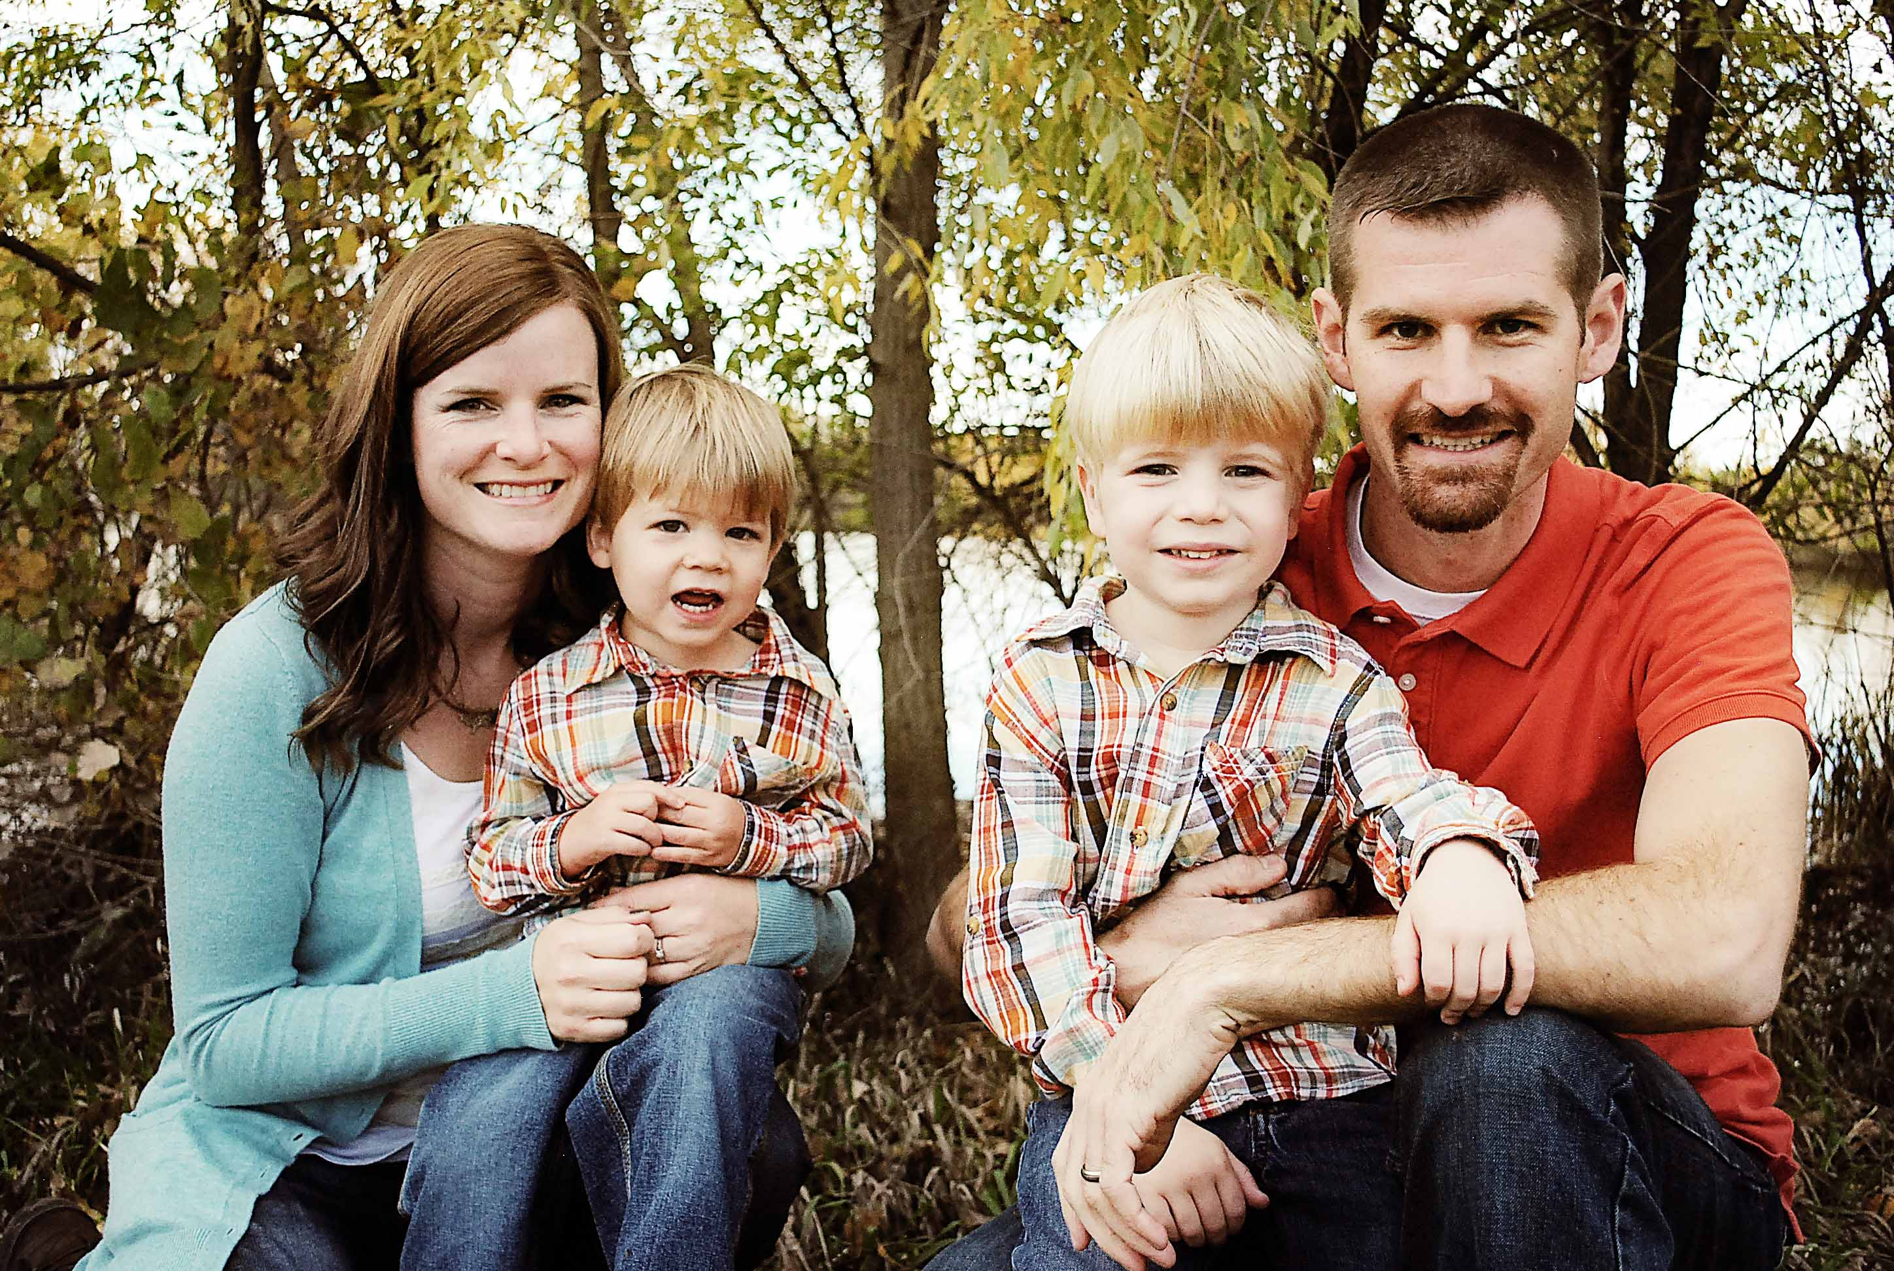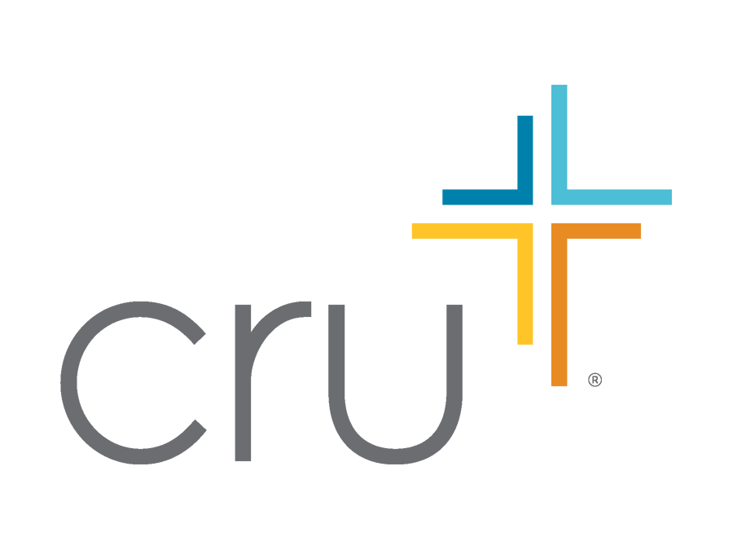

***All this is from God, who through Christ reconciled us to himself and gave us the ministry of reconciliation; that is, in Christ God was reconciling the world to himself, not counting their trespasses against them, and entrusting to us the message of reconciliation.*** (2 Corinthians 5:18, 19)

South Africa is a country that has experienced a lot of reconciliation among its people in recent years, with the guidance and example of leaders like the late Nelson Mandela. This summer, our family will spend 5 weeks in Cape Town bringing the message of reconciliation through Christ to those we meet. We will help lead 35 college students from all over the United States as we minister together to the people of South Africa. Brett is working as the Operations Director for the project. For him, that means handling all of the finances and booking of flights and lodging. It has already become a big job, but it’s been rewarding for him to see students take steps of faith by committing their summers to serving God and trusting Him to raise the support that they need.

# Update

Only a few days after we sent our last newsletter, Bryan approached Brett about sharing his testimony at a weekly Cru meeting. Brett got to meet with Bryan and found out that he had surrendered his life to Christ! Bryan shared that before college he had come to see God as a narcissistic jerk who looked down on mankind and demanded our worship and praise, but what he came to realize through his time at DCC and in reading the Bible is that God loves us and, through Jesus, came down from His throne in heaven to live and suffer and die for our sins on earth. Knowing that Jesus loved him and died for him was life-changing and gave Bryan the desire to have a relationship with God.

Thank you for your gifts and prayers that make an eternal impact on lives around the world.

## Brett and Darci Hullah

Cru at Northern Colorado

1502 Lakeside Drive

Greeley, CO 80631

(720)254-7494

[brett.hullah@cru.org](mailto:brett.hullah@cru.org)

hullahfamily.weebly.com

- Pray for other students at UNC to hear Bryan’s testimony and become excited to seek after God.

- Pray for Brett’s trip to South Africa later this month where he will make plans and reservations for the summer.

- Praise God that Bryan has begun a relationship with Jesus and is excited to tell others about his new faith!

### Prayer Requests

# Country of Reconciliation

Hullah Times